An investigation into the decline in power of the Roman Senate during the Augustan Principate

The Dataset I have chosen to use is ‘De vita Caesarum’ or ‘The Twelve Caesars’, a series of biographies about Julius Caesar and the emperors that succeeded him, written by Gaius Suetonius Tranquillus in 121 AD. I acquired the text from a website called The Latin Library (<https://www.thelatinlibrary.com/suet.html>). The text is divided into 12 parts, each one about a separate ruler. My X value is the chronological order of their reign. My Y value is the frequency of the morpheme ‘senat’ in that emperor’s biography.

Latin is an inflected language meaning the ending of words changes depending on how they are being used but the stem remains the same. Therefore, using a python algorithm, I decided to search for every instance of the sequence of letters ‘senat’ because this will capture every word relevant to the roman senate.

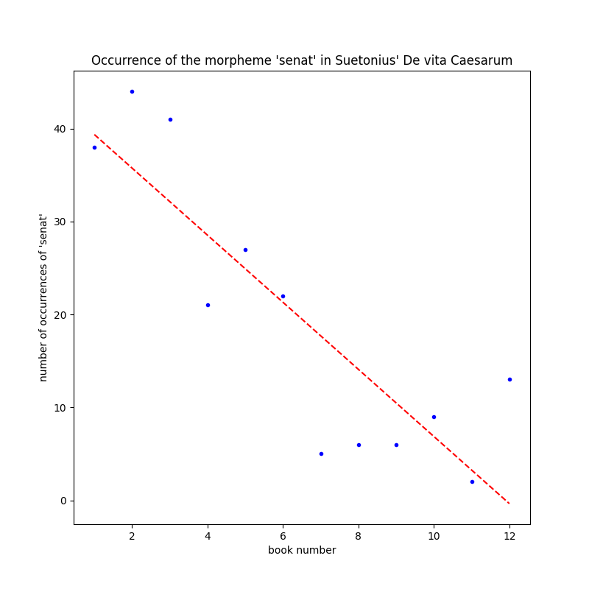

|  |  |
| --- | --- |
| Gradient | -3.61 |
| Intercept | 43 |
| R2 | 0.74 |
| MSE | 64 |
| P value | 0.0003 |

|  |  |  |  |  |
| --- | --- | --- | --- | --- |
| Summary Statistics | Position in lineage | Number of times ‘senat’ occurred in their biography | Length of emperor’s reign (years) | Length of emperor’s biography (words) |
| Max | 12 | 44.0 | 40.58 | 13900 |
| Min | 1 | 2.0 | 0.25 | 1480 |
| Mean | 6.5 | 19.5 | 10.35 | 5860 |
| Range | 11 | 42.0 | 40.33 | 12400 |
| Standard Deviation | 3.45 | 14.4 | 11.96 | 3930 |

I have calculated using Tukey Fences that any value less than -33.75 or greater than 72.25 would be considered an outlier and so there are no outliers in the dataset.

The P-value is 0.0003 which is less than 0.05 so we can reject the hypothesis that there is no relationship. The Reign of Julius Caesar and the emperors that followed marked a turning point in Roman history. Rome changed from an aristocracy, governed by the senate, to an autocracy, governed by an emperor. The negative gradient of -3.61 in usage of words relating to the senate in the text shows this change. As the senate became less relevant to the lives of the emperors and the politics in Rome, it was mentioned less in Suetonius’ account. Although the trendline graph shows that this gradient is inconsistent. The intercept of 43 shows that initially the senate was quite powerful as they are mentioned often in the text. The R2 Value of 0.74 shows that there is a correlation between the progression of rulers and the relevance of the senate to Suetonius’ account because it is greater than 0.5, however there is still room for other factors to have an influence, such as the individual emperor’s relationship with the senate. Any causality must flow from the emperor’s position in the lineage to the number of occurrences in the text because the text was written after the emperor’s reign. The Mean Squared Error of 64 shows that on average the data significantly deviates from the model.

There is likely a relationship between the two fields presented in the graph however when extending this inference to the state of Roman politics we must consider several biasing factors as we are using a literary source. In addition, the length of emperor’s reign and length of emperor’s biography both have relatively large ranges and standard deviations, both of which are likely to impact the number of occurrences of terms relating to the senate.